Val Muller Author Visit Presentations
Val offers two types of author presentations, both appropriate for elementary school ages, especially grades 3 – 5. If you have special requests or scheduling requirements, Val would be happy to work with you to schedule a customized visit to best suit the needs of your students and staff. There is no charge for author visits: instead, Val requests that the school promotes the visit and makes book ordering information available to students.
Author Presentation
This presentation spotlights the Corgi Capers series, what it takes to be an author, and information about how Val started her writing career. Students will also learn about the corgi breed and other elements of the series such as the characters’ professions and hobbies. The presentation concludes with a quiz game and prizes as well as time for a question-and-answer session. This presentation lasts 45 minutes (but can be modified according to time or age) and can suit groups of any size. Media: PowerPoint and video (projector and speakers required).
Writing Workshop
This presentation works best with a small number of students (limited to 30). In this workshop, students will be guided through the steps of creating a mystery, including a review of the writing process. It will include hands-on activities and handouts, and students will leave the workshop with a brainstorming plan for their own mystery story. There will also be time for a question-and-answer session. This presentation lasts 45 minutes (but can be modified according to time or age). Media: Powerpoint (if projector is available) and paper handouts.
Book Signings
Students will have the opportunity to have their books signed by the author. Students can pre-order books from Val’s website (www.valmuller.com/store —look for the special “elementary school visit” pricing once your visit has been scheduled), and Val will deliver signed copies during her visit. Val will also arrive with a limited number of books for students to purchase the day of the visit. (Your school can also work with Val to set up an alternate method for pre-ordering books.)

About the Corgi Capers series
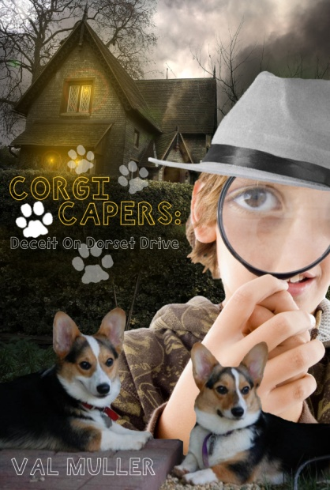
In Corgi Capers: Deceit on Dorset Drive, Fifth-grader Adam Hollinger looked forward to an ordinary summer: All-Star baseball practice, reading comic books, begging his parents for a dog, and avoiding his mischievous older sister. But things get crazy when the Hollingers adopt two corgi puppies and the team’s star pitcher breaks his arm. Even worse, a serial burglar has been targeting the neighborhood, and the Hollingers’ house is on the list. When the adults of the town become stumped, it’s up to Adam and the puppies to set things straight. Corgi Capers is the perfect book for your young detective. From the sibling rivalry to the wiggly pups that talk to each other when their people aren’t around, this book will become a favorite. The story line is intriguing, the pups are adorable, and there’s plenty of humor to keep you turning the pages until you reach the suspenseful climax.

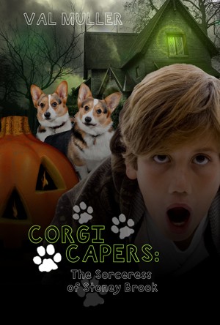
Book Two in the series, Corgi Capers: The Sorceress of Stoney Brook embroils Adam and Patrick in the scariest caper yet. The old Frostburg house has new tenants, and to Adam and Patrick, they look like witches. Belle and Cassie dress elaborately, speak strangely, and seem to know way too much about the Hollingers. Adam and Patrick read about how Logan Zephyr, their favorite comic book hero, defeated an evil sorceress and wonder if they, too, are facing real witches. When Belle asks Adam to rake leaves for her close to Halloween, Adam decides it’s a great excuse to investigate the house—or is it the perfect way for the witches to cast a spell on Adam and his best friend?

About the Author


High school English teacher by day and writer by night, Val Muller lives in Northern Virginia with her husband, Eric. She teaches English and Creative Writing in Loudoun County, Virginia. At home, she chases around her two corgis, a rambunctious and curious dog named Leia, and a kind and obedient (yet terrified) dog named Yoda. They are the inspiration behind her Corgi Capers series. She’s written dozens of short stories for children and adults, and she’s got more novels (some for adults and others for children) and a picture book scheduled for publication. To learn more about Val Muller and her story, Corgi Capers, visit her website at www.CorgiCapers.com or www.ValMuller.com.

